Math Quiz Solutions

- (20 points) TRUE or FALSE? 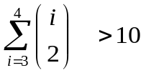 .

SOLUTION: FALSE. 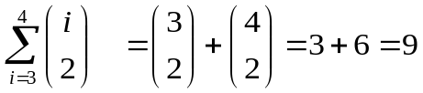.

2. (20 points) Draw an example of an undirected graph in which each vertex has degree equal to 2. Assume that the graph has 4 vertices.

SOLUTION:

3. (20 points) If you toss a pair of fair dice once, what is the probability that the sum of the numbers appearing at the top of the rolled dice equals 3?
SOLUTION: 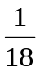. Reason: Each die has 6 sides, so the number of different possible number pairings is 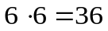. Of these 36 different outcomes, there are 2 outcomes that produce sum of 3: 1+2 and 2+1.

4. (20 points) Find the 1st derivative of 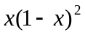 with respect to x.
SOLUTION: We apply the product rule: 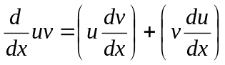 with 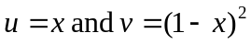. This yields: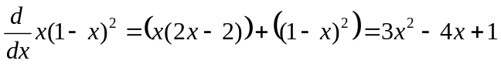.

5. (20 points) Fill in the blank: 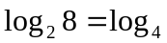 .
SOLUTION: 64. Reason: 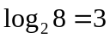and 

